FCN Retention & Recruitment Funded Project Initiative
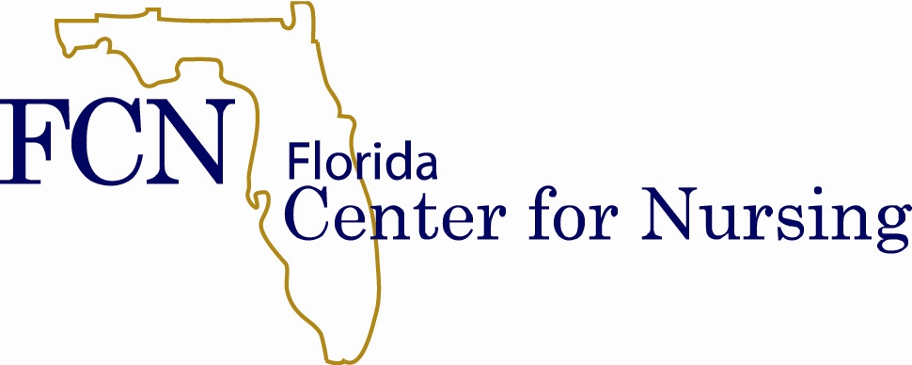

Call for Proposals Project Year 2016-2017
Due: March 25, 2016
Funding: Variable Range of Awards Available ($10,000 - $20,000)
Purpose
The Florida Center for Nursing (Center) is pleased to announce this year’s call for proposals for the FCN Retention and Recruitment Funded Project Initiative. One way the Center fulfills its mission is by funding a grant program aimed at improving the retention and recruitment of nurses in Florida. The Center’s research has demonstrated that to successfully resolve the nursing shortage in Florida, we must work to improve the retention of existing nurses in the workforce and promote targeted recruitment into nursing. Funding previously allowed us to operate a small grants program, and between 2008 and 2010, the Center provided more than $185,000 to support the work of retention and recruitment in the State of Florida.

As in times past, successful applicants will receive funding for projects that identify, implement, and/or evaluate effective solutions to maintaining and expanding the nursing workforce in Florida. Funded projects are expected to begin July 2016, and may be funded through June 2017. Quarterly progress reports will be required in October, January, and April 2016-2017. A comprehensive final report will be due no later than July 2017. Projects lasting less than one year will have individually set reporting structures. Contingent on the availability of funding, requests for 2nd year funding will be considered.
Eligibility
Funded projects may be at the facility; local; regional; or state-level, and are open to individuals or groups. Projects may relate to a specific nurse workplace setting (i.e. acute care, long-term care, home health, public health, ambulatory care, academic settings) or to a nursing group (i.e. RNs, LPNs, and/or ARNPs).
The estimated range of each award is $10,000 - $20,000. Applications will be reviewed and prioritized by a selection committee comprised of members of the Center Staff and Board of Directors.
Proposals are encouraged in the following areas, including but not limited to research or projects that:
- Obtain direct input on issues and solutions from high-risk nurse populations
  - Relate to the development, support, and retention of first-line managers
  - Support the retention of first-year novice nurses providing direct care
  - Support the retention of the maturing nursing workforce in Florida
- Prepare entry-level nurses to fill specialty-care vacancies, advance in practice, and/or seek management positions
- Support recruitment strategies targeted to qualified applicants who represent the diverse population of Florida
- Increase the ratio of men in nursing
- Implement solutions based on the experiences of first-line managers in retaining and recruiting staff nurses
- Identify the satisfiers and non-satisfiers for nurses providing direct care
- Relate to regional successes and challenges of retention and recruitment within Florida
- Examine and address the physical work environment and/or the culture of the work environment
- Serve as a pilot for long-term or large-scale retention and recruitment initiatives
Application
Proposals will be accepted on or before, but no later than, the close of business Monday, March 25, 2016. No proposals will be accepted after this date.

Applications must include all of the following elements:
- Identified primary Project Lead Investigator
- Specific problem your project addresses
- Key initiative components or activities
- Intended results or outcomes
- Intended recipient of the project or audience for the outcome
- Method for evaluation, measurement, and sharing of results
- Measurable definition of success for this project
- Detailed budget
- Statement of research methodology (if applicable)
- Other funding sources and amount (if applicable)
- In-kind contributions toward project completion and their value (if applicable)
- Statement as to how the project implements or helps identify effective solutions to maintain and/or expand the nursing workforce in Florida
Submission of Proposal
The application form may be downloaded from the R&R project page on the Center’s website. All applications must be submitted electronically by re-naming the file including the lead investigator’s name as the first part of the file name (e.g. Smith_Mary_FCN_Application.doc). Instructions are on the form.
Proposals must be submitted to NurseCtr@mail.ucf.edu no later than the close of business Monday, March 25, 2016. Only electronic submissions in the provided MS Word format will be accepted. Submission of proposal serves as agreement for project information to be published on the FCN website. Questions may be directed to the Florida Center for Nursing by email (NurseCtr@mail.ucf.edu) or by phone (407) 823-2290.
Budget Constraints
- Funds may not be used for travel to attend conferences.
- Indirect charges greater than 5% of total direct costs are not permitted.
- The use of funds for equipment is permitted only if the equipment is integral to the project and is not available within the department, institution or center. Justification must be provided.
Evaluation Criteria
Required
- Degree to which the proposed work supports the Center’s goals of directing and prioritizing nursing retention and recruitment efforts in Florida
- Sustainability plan including potential for replicability/generalizability
- Serving as a best practice, and/or establishing bench marks
- Feasibility (i.e. work plan, budget, scope)
- Innovation
- Scientific and/or technical merit of the proposed project
- Applicant’s expertise and qualifications for conducting proposed project
Preferred
- Use of funded initiatives as matching support to other agencies or organizations
- Plan for acquiring additional funding from other sources
The selection committee will assess and priority rank proposals. The notice of awards will be made by April 29, 2016. Contracts for funding will be written with the UCF Office of Research and Commercialization.
www.FLCenterForNursing.org

